VICTORIAN CIVIL AND ADMINISTRATIVE TRIBUNAL
planning and environment DIVISION
planning and environment LIST | vcat reference No. P1670/2019  Permit Application no. 600/2018/03P
CATCHWORDS
Section 79 Planning and Environment Act 1987; Nillumbik Planning Scheme; Activity Centre Zone Schedule 1; Significant Landscape Overlay Schedule 1; Mandatory height limit; Whether proposal prohibited; Front setback; Landscaping; Visual bulk; Impact on existing trees.

APPLICANT | 16 Taylor Pty Ltd
responsible authority | Nillumbik Shire Council
RESPONDENTs | Carlota Quinlan, Eltham Community Action Group
SUBJECT LAND | 14-16 Taylor Street  ELTHAM VIC 3095
WHERE HELD | Melbourne
BEFORE | Joel Templar, Member
HEARING TYPE | Hearing
DATE OF HEARING | 10 and 11 February and 19 May 2020
DATE OF ORDER | 22 June 2020
CITATION | 16 Taylor Pty Ltd v Nillumbik SC [2020] VCAT 673

Order

Amend permit application
- Pursuant to clause 64 of Schedule 1 of the Victorian Civil & Administrative Tribunal Act 1998, the permit application is amended by substituting for the permit application plans, the following plans filed with the Tribunal:
- Prepared by: | SGA Design
- Drawing numbers: | TP.01 to TP.07 all Revision G and ‘Landscape Concept Plan for VCAT’ by John Patrick Landscape Architects Pty Ltd dated December 2019
- Dated: | 19 December 2019

No permit granted
- In application P1670/2019 the decision of the responsible authority is affirmed.
- In planning permit application 600/2018/03P no permit is granted.

Joel Templar
Member

Appearances
For 16 Taylor Pty Ltd | Mr Reto Hoffman, lawyer of Rigby Cooke lawyers. He called evidence from the following witnesses:  - Ms Mika Lee, landscape architect of John Patrick Landscape Architects Pty Ltd.  - Mr John Glossop, town planner of Glossop Planning.  - Ms Debra Donald, traffic engineer of O’Brien Traffic.
For Nillumbik Shire Council | Mr Gareth Gale, town planner of Gareth Gale Planning.
For Carlota Quinlan | Ms Carlota Quinlan in person.
For Eltham Community Action Group Inc. | Ms Lynnsay Prunotto in person.

Information
Description of proposal | The proposal is to construct eight dwellings on the lot, generally in two rows in tandem arrangement. The front two dwellings would be three storeys in height with individual vehicle access direct from Taylor Street. The remaining six dwellings would be double storey in scale with a central, common driveway providing shared vehicular and pedestrian access.
Nature of proceeding | Application under section 79 of the Planning and Environment Act 1987 – to review the failure to grant a permit within the prescribed time.
Planning scheme | Nillumbik Planning Scheme
Zone and overlays | Activity Centre Zone schedule 1 (ACZ1)  Significant Landscape Overlay Schedule 1 (SLO1)
Permit requirements | Clause 37.08-5 – to construct a building or construct or carry out works.  Clause 42.03-2 – to construct a building or construct or carry out works within 5 metres from the base of any substantial tree and to remove, destroy or lop vegetation.
Land description | The review site is located on the southern side of Taylor Street and comprises a consolidated parcel of land comprising two separate lots. It has a combined frontage of 37 metres, a length of 45 metres and an overall site area of approximately 1720m².
Tribunal inspection | 6 March 2020 and 15 May 2020.

Reasons

What is this proceeding about?
- This proceeding concerns an appeal by the applicant against the failure of the council to determine a planning permit application within the prescribed time. The council’s position was that had an appeal not been lodged, it would have determined to issue a refusal to grant a planning permit.
- The council’s position was based on a number of grounds relating to front setback, scale and design, detail including colour scheme, dominance of vehicle related elements, access, spacing around buildings and impacts to trees.
- The respondents raised similar concerns to those of the council.
- In support of its case, the applicant refuted the issues raised by the council and respondents, and called three witnesses in support of its case.
- There have been a number of other proposals within the vicinity of the subject site that have been determined by the Tribunal in recent times. These were referred to variously by the parties.
- These other decisions relate to sites that are closer to the commercial core of the Eltham activity centre and are not bordered by differently zoned land. The subject site is at the southern end of the activity centre and abuts land in the General Residential Zone (GRZ) to the south.
- As was noted in G3, the strategic context of the subject site is similarly unusual in that it has the ACZ1 applying to it, but also the SLO1. The ACZ is usually applied where more intense development is expected and where matters such as vegetation and landscaping are very much a secondary factor. However, the application of the SLO1 to the subject site along with the ACZ1 seeks a different approach.
- The issues raised by the council and the respondents at the hearing essentially sit under the headings of the grounds I have set out above. These are the key issues that I must decide.
- In addition, the question of whether the proposal breached the limit of 3 storeys set out in the ACZ1 was also disputed between the parties and I deal with this matter separately.
- As the hearing was split into two separate components in February and May, the applicant saw this as an opportunity to prepare amended plans, following the second day in February and prior to the third day in May. This also followed the substitution of the plans at the commencement of the first day of the hearing. The applicant did not, however, seek to substitute these further amended plans at the resumption of the hearing in May, rather, was seeking to rely on these plans to demonstrate how the proposal could be modified to address the concerns raised by other parties during the course of the hearing days in February.
- The applicant submitted in oral submissions that these plans showed an amended front setback and reconfiguration of the front two dwellings without altering the layout of the other dwellings. This included a reduction of the floor area of these dwellings.
- I have not had regard to these plans. This is because they were prepared for the second part of the hearing in May and the applicant’s first two witnesses appeared in February and were not given the opportunity to make any comment on these plans. These witnesses gave evidence on the key issues of the front setback and landscaping. The council also objected to these plans being relied upon and was also not able cross examine the applicant’s witnesses on the proposed changes. The council’s witness was also not able to comment on these given the late stage in the hearing they were sought to be tabled.
- My findings are that the proposal is unacceptable, and I set out my reasons below.

strategic context
- The strategic context for determining this matter must be undertaken by considering the guidance found in the planning scheme, including several policies at a State level from the Planning Policy Framework, the Local Planning Policy Framework, including Clause 21.05-1 Settlement and Housing, and Clause 22.07 Eltham Town Centre Policy.
- The provisions of the ACZ1 and SLO1 provide a detailed and localised level of guidance for this proposal and the decision guidelines of the ACZ head provisions also required consideration of clause 55.
- Under the ACZ, a permit is required to construct a building or construct or carry out works unless a schedule to the zone otherwise specifies. Schedule 1 to the ACZ places the subject site within Precinct 2A where a permit is not required to use land for a dwelling.
- Clause 4.3 of the ACZ1 does not include any exemptions from permits for buildings and works and sets out that a development must meet the requirements of clause 55. It also states that any buildings and works on a lot that abuts a General Residential Zone (GRZ) must also meet the requirements of clauses 55.04-1, 55.04-2, 55.04-3, 55.04-5 and 55.04-6.
- Clause 55 sets out that requirements in a zone or zone schedule prevail over those in clause 55. The ACZ1 includes a preferred front setback from the street kerb of 5.5. metres.
- Clause 4.4 of the ACZ1 has a mandatory height provision of 10.5 metres for precinct 2A and a permit cannot be granted to vary this. As part of the mandatory height provisions, a three-storey limit is also set out with any third storey being required to be within the roof space.
- The ACZ has a series of purposes and decision guidelines that generally seek to encourage a range of uses and diversity of housing that makes best use of the facilities and services available in the centre. Design and built form considerations include:
- The design, scale, height, setback, appearance and material of the proposed buildings and works.
- The relationship between the proposed building and the public realm.
- The streetscape, including the conservation of buildings, the design of verandas, access from the street front, provision of active frontages to pedestrian areas, the treatment of the fronts and backs of buildings and their appurtenances, illumination of buildings or their immediate spaces and the landscaping of land adjoining a road.
- The interface with adjoining zones, especially the relationship with residential zones.
- The objectives, standards and decision guidelines of Clause 54 and Clause 55.
- The ACZ1 has a variety of land use objectives to be achieved, including the consolidation of the centre for different purposes, including shopping, leisure and social purposes as well as increasing the amount and diversity of housing, with particular reference to providing medium density housing for one and two person households.
- It also includes the following Built form objectives:
- To encourage more intensive development in a variety of high quality forms and design responses that respond to the Eltham form and character and create a safe, stimulating and enjoyable experience for people in the activity centre.
- To ensure that elements that contribute to the form and character of Eltham such as timber in buildings, simple, robust design elements, verandahs with timber colonnades on the outer edge and art on the façade of buildings is incorporated in developments.
- To positively contribute to the visual amenity of the area through new development and redevelopment within the Eltham Town Centre.
- To ensure building heights, setbacks and form have regard to and seek to be compatible with the surrounding development and the character of the locality in which the development is situated.
- To ensure the exterior of buildings fit the character of the area by utilising earthy toned colours and materials such as stone, wood, render and mud brick.
- To ensure that building setbacks achieve spatial proportion to the street and define the street edge, providing a high amenity for uses of the street.
- To ensure that development sites with front, side or rear setbacks are extensively landscaped with indigenous vegetation so as to contribute to the Eltham form and character.
- To ensure buildings are of a high quality design and construction and include the use of materials and colours of muted tones that blend in with the surrounding environment.
- Open space and landscaping objectives to be achieved include:
- To recognise, protect, retain and enhance the contribution provided by canopy trees, particularly native trees, to the existing and preferred character of Eltham.
- To ensure that the health of existing canopy trees is not unnecessarily jeopardised by buildings and works.
- To ensure that new development contributes to the achievement of the preferred character through additional landscaping, particularly canopy trees.
- To reinforce the indigenous planting regime within the Eltham.
- To ensure new car parking areas are provided with landscaping with canopy trees where appropriate
- The subject site sits within Precinct 2 – Residential Interface, and sub-precinct 2A.
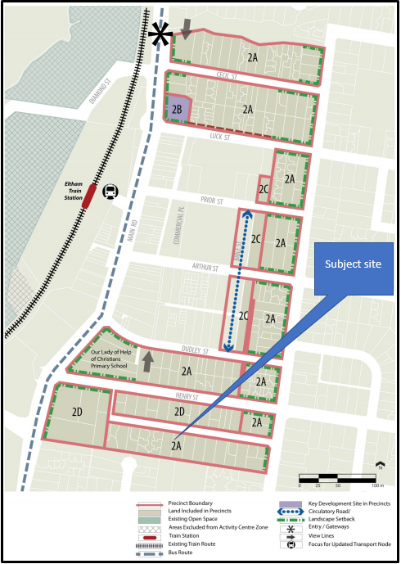

Precinct 2 Map at clause 5.2-1 of the ACZ1

- The precinct objectives for precinct 2 are:
- Encourage medium density housing, while also providing some small to medium scale office use.
- Discourage convenience restaurants (Precinct 9 is the preferred location in the Eltham Activity Centre for convenience restaurants.)
- To provide a transition in built form scale between the core commercial area and adjoining residential areas.
- To ensure non-residential development maintains a residential appearance.
- The precinct requirements are set out below in the table extracted from clause 5.2-3 of the ACZ1:
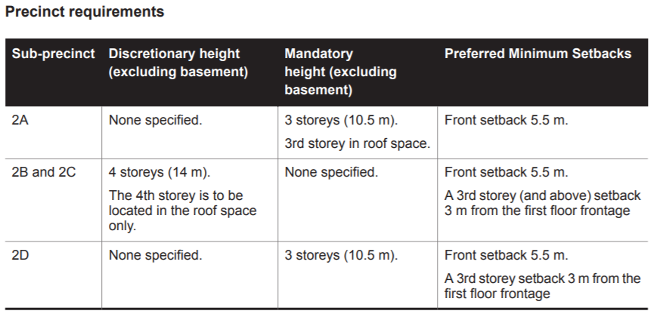
- The Precinct guidelines for this precinct include various matters and of particular relevance to this proposal based on submissions are the following:
- Main pedestrian entrances should be clearly legible from the street and demarcated with strong architectural and landscape features.
- New development should appear to have domestic quality and respond to the residential character of the area.
- Building siting should provide the opportunity for open space areas and allow for canopy tree landscaping to be integrated with the total development.
- Consideration will be given to increased residential density on consolidated development sites of 1500 square metres or greater
- New development should provide for open landscaped front yards and avoid high solid fencing.
- The SLO1 also wholly affects the subject site and triggers a permit for the removal, destruction or lopping of any substantial tree and to construct or carry out works within 5 metres of a substantial tree, which is defined as:
For the purpose of this clause a substantial tree is defined as vegetation that has a trunk circumference greater than 0.5m at one metre above ground level, and/or a height greater than 6 metres
- In this case, a permit is triggered for buildings and works under the SLO1 based on the proximity of the proposal variously to trees 12, 13, 14, 18, 27 and 34.
- No trees are proposed to be removed that would be triggered by the SLO1.
- The SLO1 seeks the following preferred character:
- New development will employ earthy muted tones, natural building materials and innovative design.
- Buildings will not exceed the predominant tree canopy height and while visible from the street, their appearance will be softened though landscaping.
- Building forms will be modest and compact in scale and avoid excessive bulk through the use of articulation, low roof pitches, and other design elements.
- Vegetation, both native and exotic canopy trees, will dominate long distance views, the skyline of streetscape views, and front gardens.
- There will be little physical evidence of the boundary between private and public property at the front of buildings, and no solid fences.
- Landscape character objectives to be achieved are:
- To recognise, protect and enhance the contribution provided by canopy trees, particularly native trees, to the existing and preferred character of the Eltham Town Centre.
- To ensure that the health of existing canopy trees is not unnecessarily jeopardised by buildings and works.
- To restrict removal of vegetation to the minimum required to allow land to satisfy its development potential in accordance with the Eltham Major Activity Centre Structure Plan (August 2004).
- To ensure that new development contributes to the achievement of the preferred character through additional landscaping, particularly canopy trees.
- To reinforce the indigenous planting regime within the Eltham Town Centre.
- Decision guidelines of the SLO1 Include:
- Whether the design of any proposed buildings and works has been adequately responsive to the objective of avoiding and/or minimising the extent of vegetation removal, destruction or lopping.
- The need for additional landscaping and screen planting to contribute to the achievement of the preferred, landscape qualities of the Eltham Town Centre.
- Whether the proposed landscaping is of a high quality and uses indigenous species, including canopy trees.
- The extent to which front setbacks are landscaped to reinforce the appearance of vegetation dominating private allotments when viewed from the street.
- The decision guidelines at clause 65 and provisions at clause 71.02 are relevant have also been considered.

physical context

Subject site
- The subject site is located on the south side of Taylor Street in Eltham. It comprises two lots with a combined frontage of 37 metres, a length of 45 metres for an overall site area of 1720 m². The subject site slopes upward steeply from Taylor Street to the rear as well is slightly to the east. The upward slope from the front to the rear of the site is approximately seven metres from the north-west corner upwards to the south-east corner.
- The site is currently occupied by double storey dwelling located towards the eastern side of this site and towards the rear south-eastern corner. Two vehicle crossings are located on Taylor Street on either side of the site, with a circular driveway connecting the two. There is little vegetation existing on the site with the only vegetation being located within the circular driveway area and some small trees located along the eastern boundary. There is a rock retaining wall that abuts the footpath and which forms part of the road reserve.

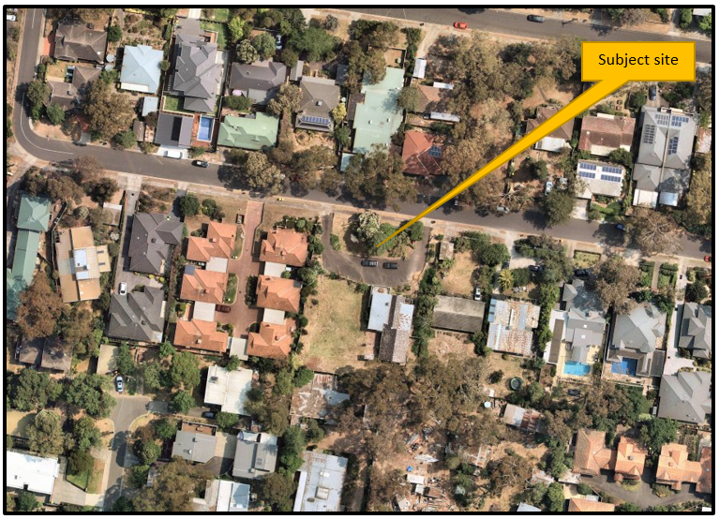

Subject site and surrounding properties. Source: Nearmaps, image taken 19 December 2019

- The road reserve at the front of the subject site is somewhat unusual in that the interface between the subject site and the road reserve is approximately 2.4 metres back from the edge of the footpath, resulting in a strip of land or nature strip between the footpath and the front boundary of the subject site. In many urban settings this does not occur, however, there are other examples nearby in the surrounding area of Eltham where a similar scenario exists.
- This strip of land continues along almost the full length of Taylor Street along its southern side. When viewed on site, it is difficult to discern between where the front property boundaries of sites end and the road reserve begins in part because some properties do not have front fences and also because it appears that adjacent property owners have either planted and/or maintain landscaping within this area.

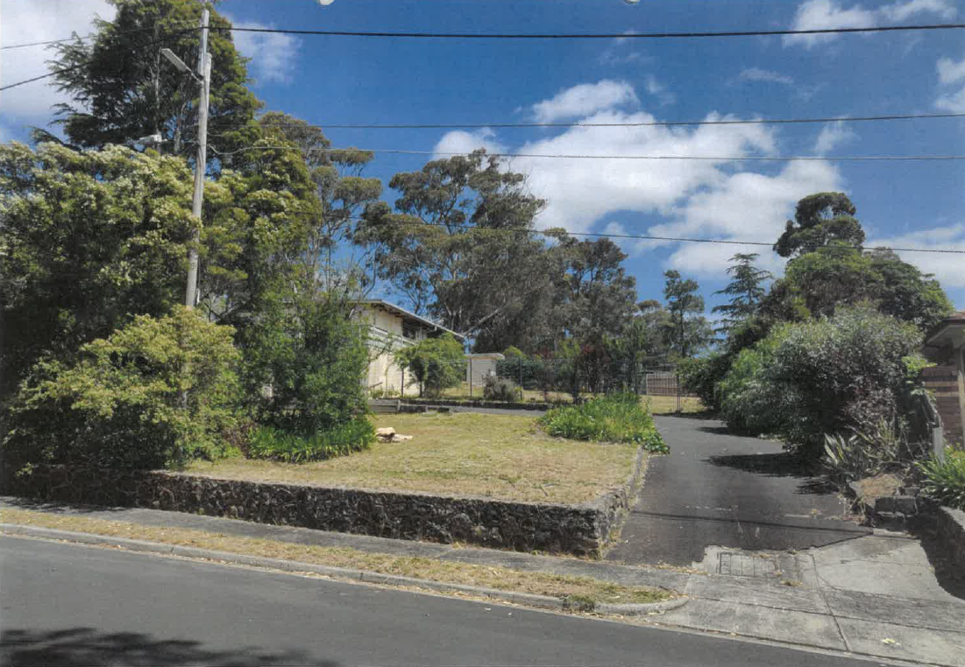

Subject site, western aspect. Source: Council submissions.
- There is also an existing retaining wall at the rear of the existing dwelling and within the TPZ of tree 18 on the adjoining property.

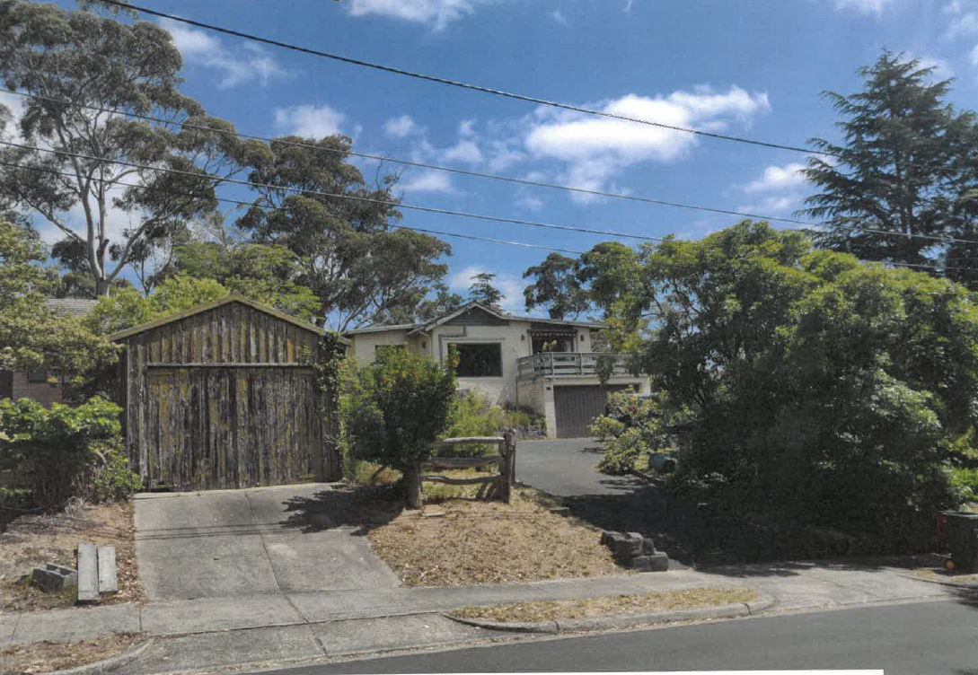

Subject site, eastern aspect with the dwelling on the subject site to the right and the garage at 18 Taylor Street to the left. Source: Council submissions.

Abutting and opposite properties
- The subject site has a number of direct abuttals with other properties.
- To the west, there are three dwellings facing the subject site forming part of a six dwelling development at 10-12 Taylor Street. These three dwellings are all single storey in scale, and located within approximately 2.0 metres from the common boundary. They also have areas of secluded private open space abutting the boundary with the subject site. There are some small trees and other vegetation within these secluded private open space (SPOS) areas.
- To the east is a relatively modest single storey dwelling at number 18 Taylor Street which is located centrally on that site. This site also supports a small single storey garage located in the north-west corner abutting the Taylor Street road reserve.
- To the rear or south there are two separate properties abutting the review site, both of which support a significant amount of vegetation, including two very large native trees close to the rear boundary and which have significant proportions of the canopy overhanging the subject site.
- The first towards the south-west, supports a single dwelling located centrally on the site with a large outbuilding constructed on the rear boundary.
- The second, towards the south-east, supports a number of buildings on a particularly large lot. None of these buildings about the review site.
- The context opposite the review site presents a mixed character. The original subdivision pattern of the land to the north appears to be lots that was subdivided with a primary frontage to Henry Street which is the next Street to the north, and a secondary frontage to Taylor Street. This is evidenced by most dwellings fronting Henry Street with outbuildings and garages towards the rear and visible from Taylor Street.
- However, there has been some development of the rear of these lots where dwellings have been retained at the front, fronting Henry Street with some dwellings being constructed at the rear and now having frontage to Taylor Street.

Broader context
- The subject site sits on the southern edge of the Eltham Activity Centre and approximately 300 metres south of the central commercial core of Eltham and approximately 450 metres from the Eltham railway station.
- Development in the immediately surrounding area is a mixture of single storey dwellings with the occasional three storey dwelling. However single storey dwellings at least from some perspectives, appear to have a greater presence owing to the fall the land in this part of the locality, where floor levels appear to be consistent across sites resulting in slightly elevated built form visible from some parts of the public realm.
- Vegetation is clearly evident with many examples of large eucalyptus species spread throughout both the private and public realms.
- There is no consistent pattern of the location of built form on private property with some being located towards the front, some to the rear and some centrally.
- There is evidence of multi-dwelling development in the surrounding area, a result of which is a higher degree of site coverage and lesser presence of vegetation, particularly towards the centre and rear parts of such sites.

is the scale of the building prohibited under the acz1?
- The council submitted that the proposal is three storeys, with dwellings 1 and 2 having a semi-basement garage that projects in the order of 1.2 metres above the natural surface of the ground and two further storeys above each.
- The council submitted that this breaches what it initially submitted was a ‘mandatory’ limit of three storeys that is set out in the ACZ1.
- The ACZ1 sets out the following:
- Under the Mandatory height column of the above table, there are two ‘limbs’. This first is a maximum height of 3 storeys. The second is that the 3rd storey is required to be located within the roof space.
- The applicant submitted that this matter had been previous dealt with in the Eltham Outlook case, where a specific point of law was raised and determined by a legal member.
- In that decision, the question of law was framed:
Does the phrase, ‘3rd storey in roof space’, as appears in Part 5.2-3 on page 13 of Schedule 1 to the Activity Centre Zone to the Nillumbik Planning Scheme, and applies to Precinct 2A, act as a mandatory requirement, that cannot be amended with the grant of a permit?
- The determination of that question of law was:
27. The expression ‘3rd storey in roof space’ in the table to clause 5.2-3 of Schedule 1 to the Activity Centre Zone relating to sub-precinct 2A is not a mandatory requirement. Pursuant to clause 37.08-5 of the Activity Centre Zone, a permit may be granted to construct a building that is not in accordance with this requirement.
- In this case, there is dispute about whether indeed the building is three storeys or two. Therefore this issue becomes relevant.
- The council argued it was three storeys and that the third storey of dwellings 1 and 2 was not contained within the roof space. On this basis, the council initially submitted that the proposal was therefore prohibited but conceded in reply that the ‘3rd storey in roof space’ was not a mandatory requirement.
- The applicant argued that at no one point, the building was more than two storeys and so the question of the second limb to the mandatory height control, was not even in question.
- It appears to me that parts of the proposal are more than two storeys, being parts of dwellings 1 and 2 and so the second ‘limb’ becomes relevant.
- However, in reply, the Council conceded that the second ‘limb’ was not in fact a mandatory requirement.
- The legal opinion in Eltham Outlook was that the ‘3rd storey in roof space’ aspect of the mandatory height provision is not a mandatory requirement and that a permit may be granted to construct a building that is not in accordance with this requirement.
- I do not depart from this finding given the circumstances of the matter before me. I also acknowledge that the council now accepts it is not a mandatory provision and that it is a discretionary matter that I can consider.

is the built form acceptable?

Front setback and landscaping
- Much of the hearing time was devoted to whether the presentation of the proposal to the street was acceptable. Primarily, this related to whether the front setback, scale of the development to the street and landscaping at the front of the site were appropriate.
- The ACZ1 sets a preferred minimum front setback of 5.5 metres. It is a preferred setback and a minimum. It is not mandated and can be varied. Therefore, context is imperative.
- The dwelling on the adjoining property to the east is setback a significant distance and the parties conceded that matching this setback or in arriving at the B6 average, including this dwelling setback was not appropriate.
- It was Mr Glossop’s evidence that B6 was met as it specifically refers to meeting the requirement in a schedule to the zone, which the proposal does meet (the 5.5m minimum). He also said that meeting the standard equals meeting the objective and stated that a number of previous decisions of the Tribunal, including by legal members, had clearly set this out. He also said that such decisions or findings were binding on other divisions of the Tribunal.
- I disagree. They may be persuasive, informative and may be relied upon or referenced. There may well need to be very good reason to depart from such rulings or findings, but that does not mean they are binding.
- In the case of meeting standards of clause 55 and whether doing so means there is automatic satisfaction of the corresponding objective, this continues to be unresolved. It was Mr Glossop’s evidence that meeting the standard ordinarily meant that the objective was met. However, he also conceded that simply meeting the ‘barn’ diagram in standard B17 of clause 55.04-1, for example, was not the only determiner of whether a side and rear setback of a proposal was acceptable. He agreed that there are qualitative elements to that clause.
- In my view, qualitative considerations are included in the objectives and decision guidelines of clause 55.
- If Mr Glossop’s logic were applied regarding compliance with the standard equals compliance with the objective, then what becomes of the Decision Guidelines under each clause 55 sub-clause if the standard under each were met? Are they simply ignored? This cannot be the case. Under every clause 55 sub-clause, there are a suite of decision guidelines and the preamble to each states:
“Before deciding on an application, the responsible authority must consider:…..”
- It does not include any qualifying prefix such as ‘If the standard is not met…’ or words to that effect.
- The ultimate guidance, in my view, comes from clause 55, where, under the ‘Operation’ section, it sets out the following:
Decision guidelines.
The decision guidelines set out the matters that the responsible authority must consider before deciding if an application meets the objectives.
- Clause 55 does not set out that if the standard is met, the decision guidelines are not applicable.
- The decision guidelines must be considered before deciding an application.
- I accept that there are differing views amongst various divisions of the Tribunal on this issue. I also accept that decisions by legal members in the past have differed from my views and those of other Tribunal decisions.
- The objectives, standards and decision guidelines in clause 55 provisions must be read together in order to arrive at a decision about whether the objective has been met.
- The objective of clause 55.03-1 seeks buildings that respect the preferred character and make efficient use of the site. Standard B6 related to this objective seeks that walls of buildings be setback at least the distance specified in the schedule to the zone. The decision guidelines under clause 55.03-1 include:
- Any relevant neighbourhood character objective, policy or statement set out in this scheme.
- The design response.
- Whether a different setback would be more appropriate taking into account the prevailing setbacks of existing buildings on nearby lots.
- The visual impact of the building when viewed from the street and from adjoining properties.
- Clearly, there is a balance to be struck between meeting the preferred character outcome and efficiently using land which has been designated for greater density, given the application of the ACZ1.
- In this case, there is a preferred setback of 5.5 metres from the kerb.
- The minimum setback of the building is proposed at 7.618 metres from the kerb which meets the numerical preferred setback.
- However, I am not persuaded that the proposed front setback is an acceptable response in this streetscape.
- Whilst I give significant weight to the proposal’s compliance, and indeed, exceedance of the preferred 5.5 metre setback, I find that an assessment cannot merely look at the quantitative outcome. The objective under clause 55.03-1, and the decision guidelines of this clause as well as both the ACZ1 and SLO1 require a qualitative assessment to be undertaken. As a result, I find the proposal presents poorly to the street, with a minimal front setback, and an extent of development that will dominate the public realm views, with minimal opportunity for landscaping.
- The proposed units 1 and 2 occupy a significant proportion of the site frontage width, coupled with three driveways, two of which splay outwards from the frontage to the respective facades. Further, the porches and stairs to each of the front dwellings also occupy a significant proportion of the frontage setback areas. Whilst these features are technically exempt from the numerical front setback requirement, they only serve to add to the sense of bulk and massing that the proposed front units present.
- The elevated position of the site above Taylor Street accentuates the presence of these dwellings, with elevated floor levels and a projecting garage above natural ground level.
- There was some criticism of the ‘false’ gable facades creating a greater sense of bulk. I agree that the gable elements add to a sense of scale, particularly given the design the front dwellings has not appropriately accommodated the fall of the land. These two aspects provide a sense of overbearing scale that I find is not supported in this streetscape, at the edge of the activity centre and where a minimal front setback has been provided.
- I otherwise do not have any concerns with the design detail of the facades, with the emphasised triangular appearance. I find the design innovative and reflective of the differing forms found in the surrounding area. Although the brighter colours were raised as being of concern, I am not persuaded that the colour scheme could not have been resolved through appropriate conditions, even though colour schemes are a specific consideration under the ACZ1.
- In terms of landscaping, the applicant relied on the front setback but also, and quite more significantly, the road reserve for complimentary landscaping, particularly canopy trees.
- The landscaping concept plan of Ms Lee shows four Red Box eucalyptus trees along the frontage in the front nature strip and not on the subject site. Her plan identifies that these trees could grow to 15 metres in height in this location. Other trees are also proposed as well as lower storey planting.
- Under cross examination, Ms Lee accepted that these trees are proposed underneath existing overhead wires of which, it became apparent, she was unaware of when preparing her plan. When questioned about the suitability of these trees in such a location, Ms Lee stated that these trees could be pruned.
- I was referred to the findings in G3 referred to me by the council, where, at paragraph 32 of that decision the Tribunal made the following findings with respect to the assessable landscaping being that which is proposed within the boundaries of the subject site:
32. The proposed development for the review site anticipates the planting of additional landscaping within the public realm to Circulatory Road as part of the proposed development of the review site. Indeed, the landscape plan prepared by Mr Patrick details the nature of that landscaping that the Applicant proposes to undertake. While we agree that landscaping opportunities exist within the public realm adjacent to the eastern boundary of the review site, we consider that we need to assess this proposed development on the basis of the landscaping opportunities that are to be achieved within the boundaries of the review site itself. That is particularly the case in this dispute, where the Council opposes the proposed landscaping within the public realm that the Applicant wishes to undertake.
- I adopt a similar approach to that in G3. I find that the landscape concept to use Red Box trees in this location is flawed based on both the inclusion of them outside the subject site (for which any permit issued under this proceeding has no control) and the unsuitability of the species given the constraints imposed by existing infrastructure.
- In my view, Red Box trees are not the type of tree that would be ordinarily pruned in such a manner and even if they were, doing so would not suit the broader setting of the site in Elham, which has a strong landscape character of informality that comes with indigenous and native eucalyptus species.
- This then, in my view, defers consideration of the landscaping treatment to the front setback area, which, as I have already set out, is heavily constrained by the minimal setback of the proposal from the front boundary and the associated built form of driveways and porches.
- The landscape plan otherwise includes four lemon scented gums, nominated to grow to a height of 8 metres in height, with other understorey planting within the front setback of the site itself. These canopy trees are proposed more to the sides of each dwelling, rather than centrally. The ability to have larger canopy trees centrally is again constrained by the porches and stairs of the front dwellings, which reduce the area of open space that can be landscaped.
- Further, the narrow strips of landscaping on either side of dwellings 1 and 2 between the walls and the central driveway are insufficient for significant landscaping to be accommodated. These strips are approximately 450mm wide and Ms Lee’s plan shows climbers to be planted only. In my view, this demonstrates the limited space available and therefore the limited contribution the proposal exhibits to the streetscape.
- In addition, the proposed three driveways across the frontage further reduce area for landscaping.
- Whilst I deal with spacing between and around the proposed dwellings in the following sections, the inability to include significant landscaping at the front of the site, the attached nature of each row of dwellings and the rising topography from the street will result in the proposal having significant visibility from various vantage points, which is what the SLO1 seeks to avoid that cannot otherwise be softened with landscaping at the front of the subject site.
- The scale and presence in the street of the proposed buildings is exacerbated by the minimal front setback and inability of the site to include its own landscaping. I find this will result in an unacceptable balance between increased built form and landscaping suitable for this physical and strategic context.
- The built form will not be softened through landscaping that can be accommodated on the subject site due to the small front setback proposed. In this case, I find that the balance between increased density, as encouraged by the ACZ1, and a suitable landscaped setting is weighted too far on the side of increased density with the streetscape dominated by built form with lack of suitable landscaping.

Spacing between and around buildings
- The council submitted that the spacing between buildings and around the site was inadequate to allow suitable landscaping. It said this would be contrary to achieving the objectives of the SLO1.
- The SLO1 aims to achieve general increased landscaping outcomes, as well as retaining existing vegetation. However, the focus of new planting appears to be towards an appropriate landscaping outcome as seen from the street. This is not to say parts of sites beyond the frontage presentation are ignored, but the emphasis appears to be on streetscape and longer-view presentations.
- I am not persuaded that the proposal would be an unacceptable outcome with respect to landscaping throughout the site.
- I find there is adequate space in which to include canopy trees and other landscaping in order to achieve an acceptable outcome.
- Each private open space area of the proposed dwellings could accommodate either at least one canopy tree or retain an existing tree. In some cases, such as the two rear dwellings, multiple canopy trees are proposed.
- Whilst the proposal is for two rows of four attached dwellings which does not allow space between each dwelling, there is landscaping proposed along parts of the central driveway which can accommodate trees, as well as in the area beyond the termination of the central driveway, between that and the rear boundary which will result in a balance between what the planning scheme seeks.

will there be any unacceptable impacts on trees?
- The council and Ms Prunotto raised concerns with the impact the proposal would or might have on nearby trees. In particular, tree 18, located on the adjoining property to the south, was of concern in relation to the construction and excavation required for dwelling 8. Tree 18 would require a permit for its removal, destruction or lopping under the SLO1 provisions.
- The arborists report submitted by the permit applicant to the council assessed tree 18 as being of high protection value and medium arboricultural value. It is 22 metres high with a canopy spread of 20 metres and noted as a Sugar Gum. Its canopy extends significantly over the subject site, with the trunk approximately 1.5 metres from the common boundary. The arborists report also notes that it requires pruning but does not state whether this is for arboricultural reasons or to accommodate the proposal. It also notes that it is of fair health, poor structure and mature. The council’s arborist noted that this tree is in decline and the species tends to drop branches when old.
- Dwelling 8 would be constructed within a significant proportion of the tree protection zone (TPZ) of this tree.
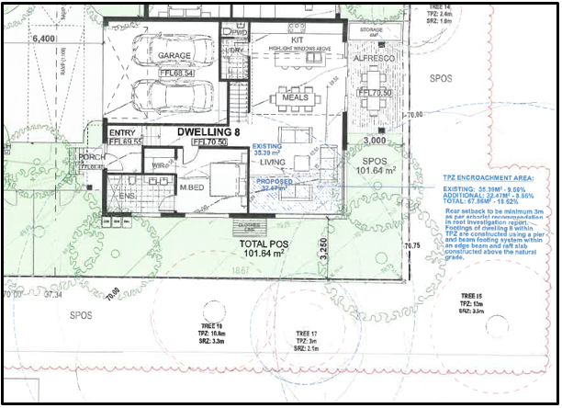

Extract of proposal showing dwelling 8, with TPZ of tree 18 shown with dashed blue line.
- The applicant’s arborists report considered the existence of tree roots of tree 18 within the subject site. Root investigations were undertaken during the design phase of the original proposal and included hydro trenching to a depth of 600mm and for the length of the TPZ, at 1.5 metres from the rear boundary of the subject site.
- Within the ‘Specific Recommendations’ section of this report in section 6.3, it indicates that the area between the building footprint of dwelling 8 and the southern boundary within the TPZ of tree 18 is to remain at existing grade in order to protect the tree.
- This report also recommends that any excavation for the footings of tree 18 are to be undertaken under the supervision of an arborist. It also recommends pier and beam footing construction method with edge beam and raft slab construction.
- Ms Prunotto submitted that the proposal will unacceptably impact this tree for two reasons.
- Firstly, the footings proposed will extend into areas where roots of tree 18 exist.
- Secondly, and it appears to me independently of what type of footings are proposed, drainage uphill of footings is generally required to ensure the integrity of any such foundations. Such drainage would require excavation to occur beyond any foundations and these would extend further into the TPZ of tree 18.
- The council’s arborist recommended an above grade footing system.
- Based on both the council and applicant’s arborist, it appears that an appropriate foundation system could be accommodated under arborist supervision.
- However, in my view, further detail needs to be known with respect to two areas of concern I have.
- Firstly, there remains doubt about any associated drainage required for such foundations and how this would operate in a practical sense. Whilst foundation construction could potentially avoid or mitigate damage to existing roots, it is unclear how required drainage would do this, given the lineal nature of drainage infrastructure.
- Secondly, the condition of the tree and its potential to drop limbs is questionable to the extent that I cannot be satisfied to an acceptable level that the tree will not drop limbs on dwelling 8. Such an outcome could then pose future risks to that dwelling and potentially force the removal of the tree.
- I am therefore not persuaded that the application has dealt with these issues to a level where I can be satisfied they could be adequately dealt with through permit conditions.
- These matters should be addressed in any further permit application.

Are there any other issues?
- The council, including through Ms Roberts’ evidence, raised concerns with pedestrian access for dwellings 3 to 8. In particular, concerns were raised with respect to safety of the shared access and poor sense of address for these dwellings. The overall poor amenity for pedestrians, including the steepness of the driveway was also raised. The council said that the aperture between each part of the front dwellings where they are adjacent the driveway, is so narrow that it disguises the entries of these dwellings and provides poorly delineated access.
- Ms Donald’s evidence was that there is no safety issue with the driveway being shared, as the driveway is a low-volume, low-speed vehicular environment and the prospect of conflict is low. She also stated that if there was a conflict, the layout was not so problematic that pedestrians and vehicles could not manage such a scenario.
- The applicant submitted that such an arrangement is commonplace in Eltham and cited a number of other examples of where townhouse developments providing access to the rear, did not include a dedicated pedestrian path. It also said that providing a pedestrian path would be an inefficient use of land, providing more hard surfaces without practical benefit.
- Clause 52.06 seeks to ensure that design of car parking creates a safe and efficient environment for users and I accept that this means pedestrians and vehicles in the context of this proposal.
- I am not persuaded that a separate pedestrian path is necessary for an acceptable outcome. I am also not persuaded that a separate pedestrian path is required for a safe shared accessway. The traffic environment is low-speed and low-volume where the potential for conflict is low based on the number of dwellings gaining access from this central driveway.
- However, I agree with the council that the delineation of access and the sense of address for the rear dwellings is poor. This is created by the narrowness between the front two dwellings where the space between them is mostly occupied by a driveway, with little landscaping and dominant built form on either side. Greater legibility and delineation for access to the rear dwellings should be addressed with any further application.

Conclusion
- In my view, the subject site is suitable for some form of more intense development. The zoning of the land, its proximity to shops services and facilities, including the Eltham railway station, it’s generous size and shape all weigh in favour of some form of higher density development. The planning scheme provides an expectation of some further, more dense development of this site.
- However, the proposal fails to acceptably address some key aspects of what the planning scheme seeks to achieve. In summary, the primary issues relate to how the proposal addresses the public realm and also the response to an existing tree on an adjoining property to the rear. Whilst perhaps somewhat limited, I have found that these issues are not able to be adequately addressed by conditions on a permit and if a proposal of a similar layout were pursued, these matters should be addressed through a new permit application.
- For the reasons given above, the decision of the responsible authority is affirmed. No permit is granted.

Joel Templar
Member

Section 4(2)(d) of the Victorian Civil and Administrative Tribunal Act 1998 states a failure to make a decision is deemed to be a decision to refuse to make the decision.
The submissions and evidence of the parties, any supporting exhibits given at the hearing and the statements of grounds filed have all been considered in the determination of the proceeding. In accordance with the practice of the Tribunal, not all of this material will be cited or referred to in these reasons.
G3 Projects Pty Ltd v Nillumbik SC [2019] VCAT 263, Eltham Community Action Group v Nillumbik SC [2018] VCAT 1952, Eltham Outlook Pty Ltd v Nillumbik SC [2017] VCAT 675, Flory Pty Ltd v Nillumbik SC No.2 [2017] VCAT 252
At clause 2.0 of the ACZ1.
Ibid.
Ibid.
Several trees have been removed from the site under bushfire exemptions in the planning scheme.
Page 10, Development Impact Assessment by Abor Survey, 8 November 2018.
4, 10 and 26 Taylor Street and 91 Bridge Street, all in Eltham.

